**Online Toy Car Shop**

**\*First Version (Mar 22, 2016 ~ Mar 30, 2016)**

**\*Functions:**

-Category is classified

-Details of Items

-Item Add and Remove

-Item Discount

-Search Item (modifying)

Main Page

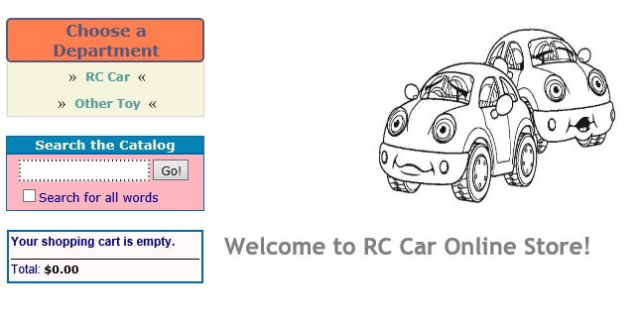

Click RC Car Department

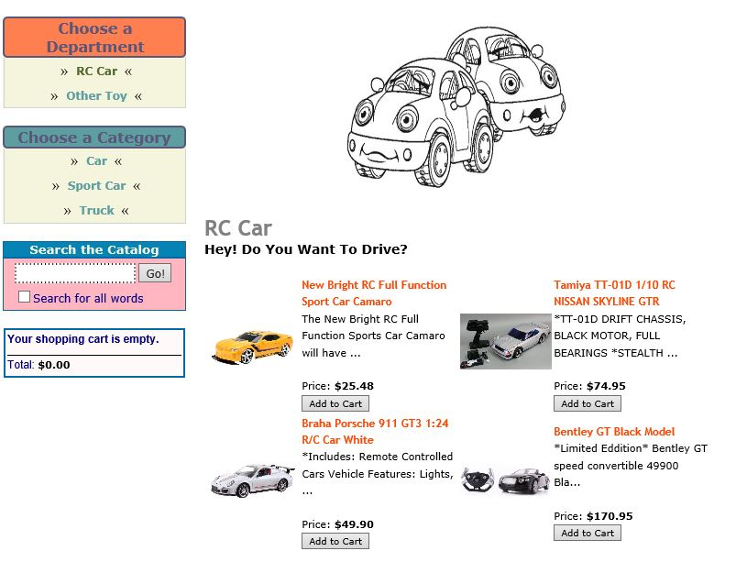

Click Car Category

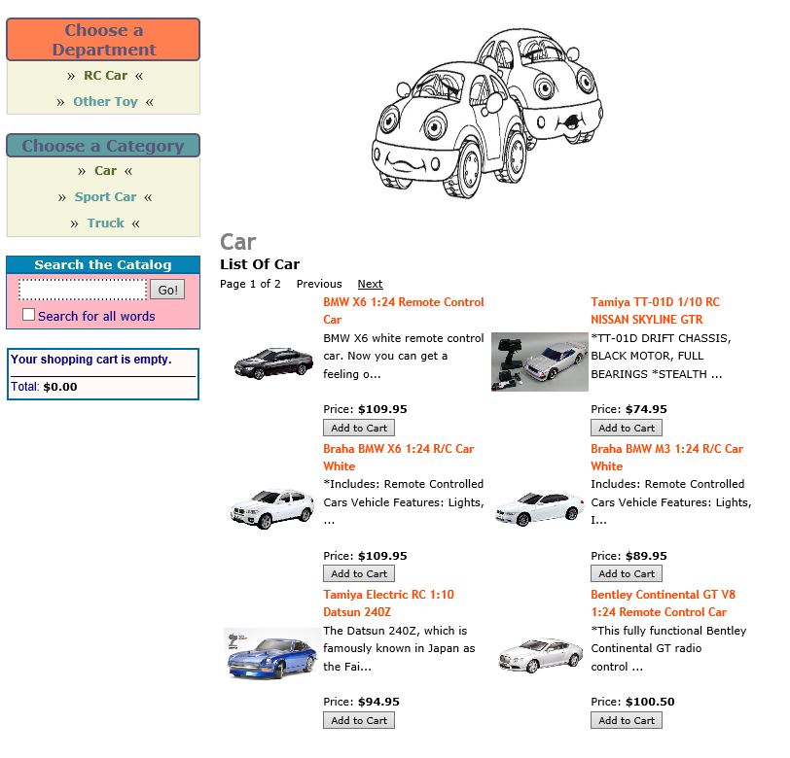

Second Page

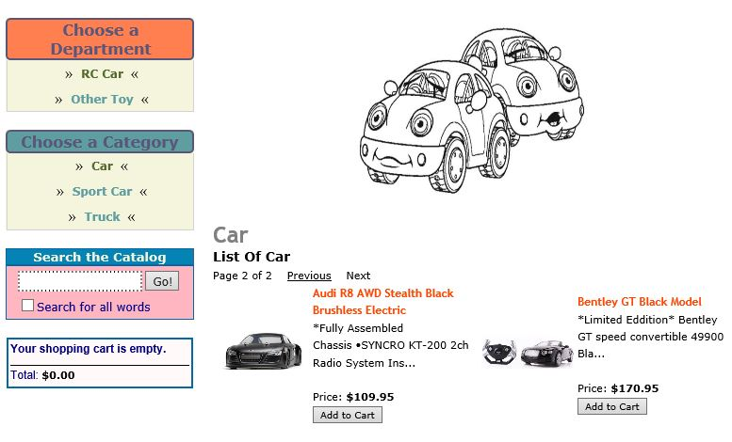

Click Sport Car Category

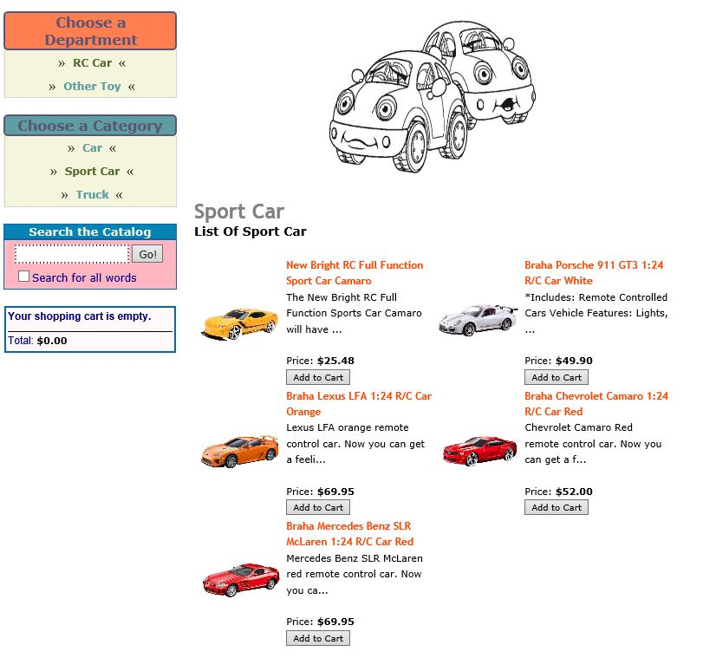

Click Truck Category

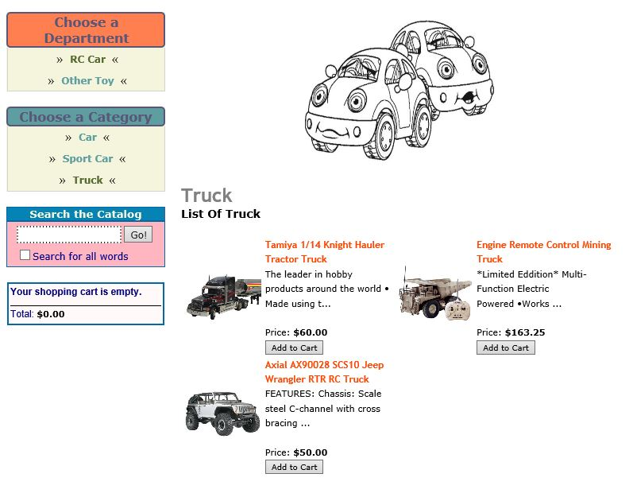

Click Other Toy Department

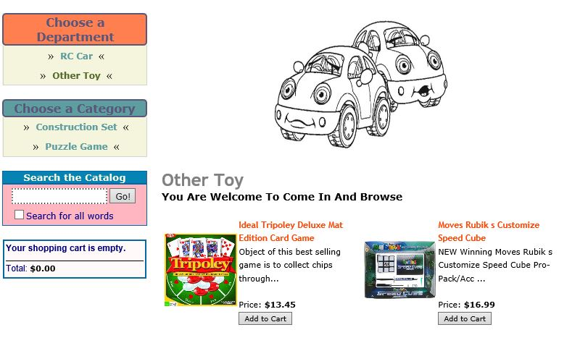

Click Construction Set Category

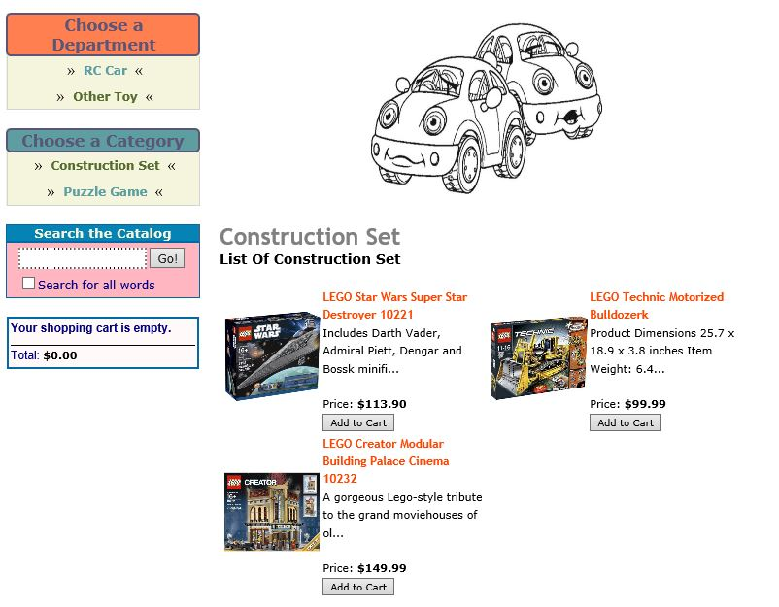

Click Puzzle Game Category

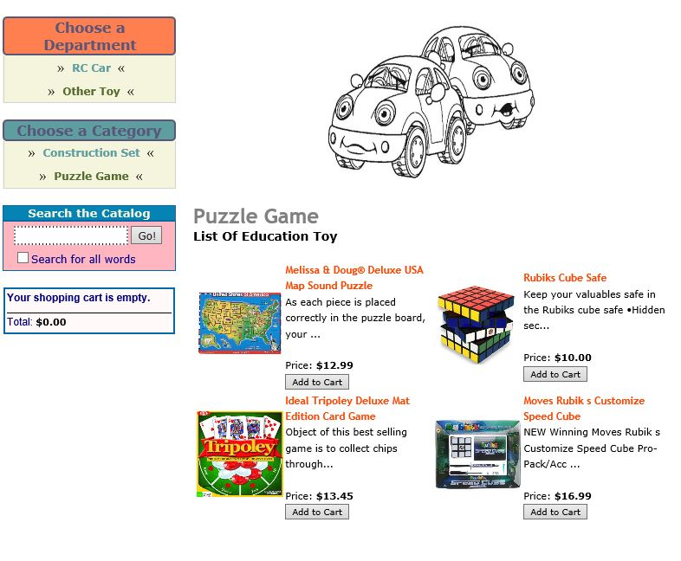

Empty Shopping Cart

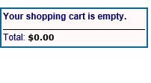

Add Item: Change total price in the Shopping cart

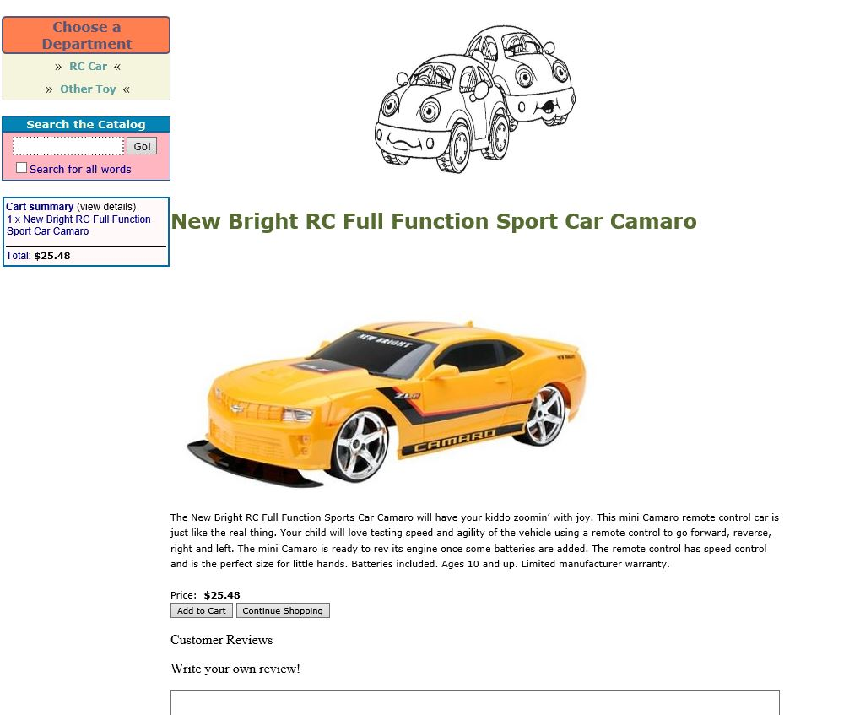

Click View Details

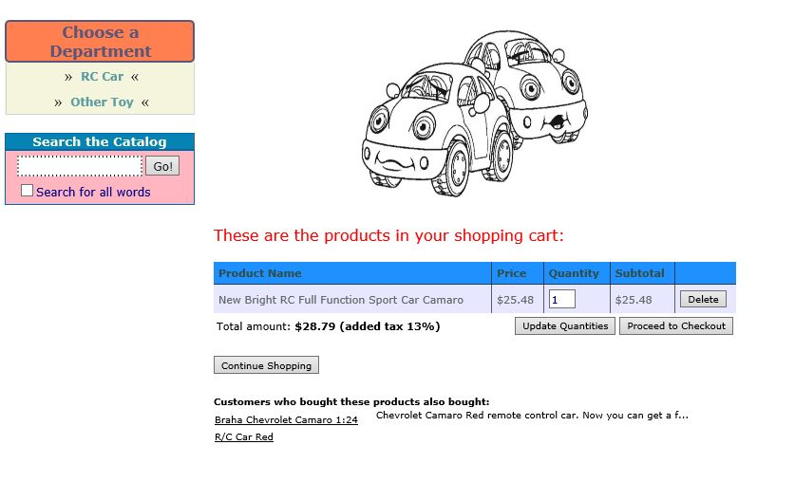

Total price is < 100$: Added tax 13%

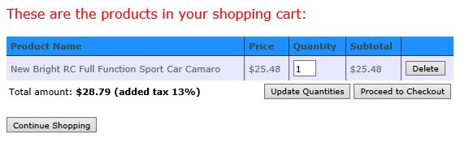

Total price is > 100$ and < 200$: No Tax added

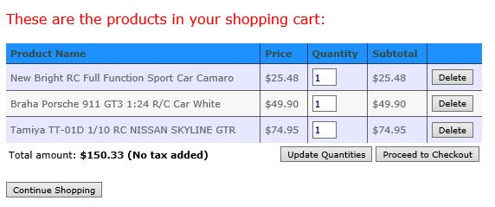

Total price is > 200$: No tax and 10% discount

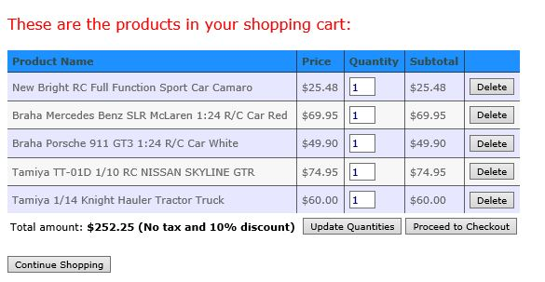

Update Quantity

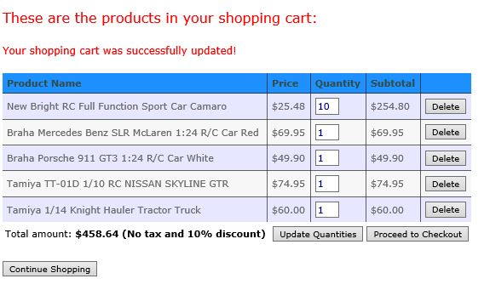

Remove Product

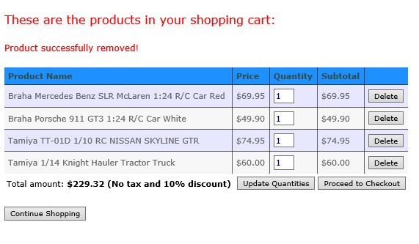

Click Proceed to Checkout: Connect with PayPal

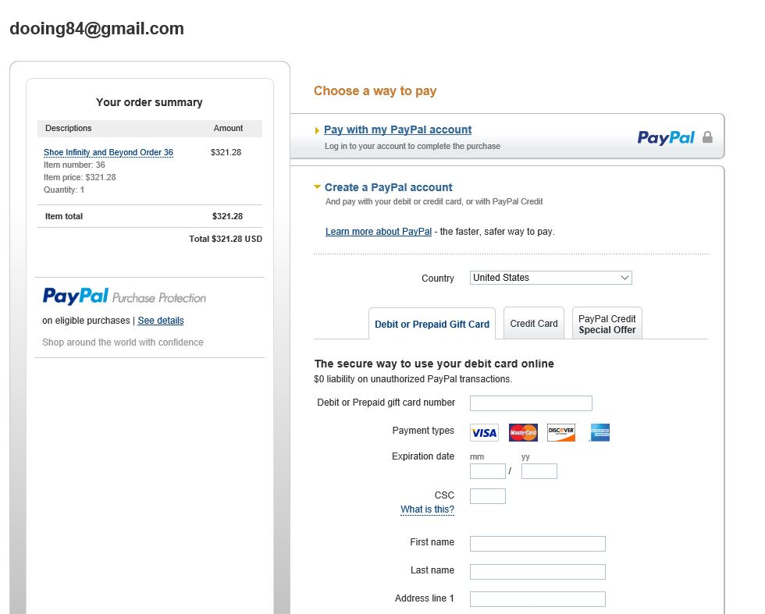

**\*Second Version (Mar 31, 2016 ~ Apr 07, 2016)**

**\*Functions:**

-Registration for users

-Login

-Review

Click Create an Account

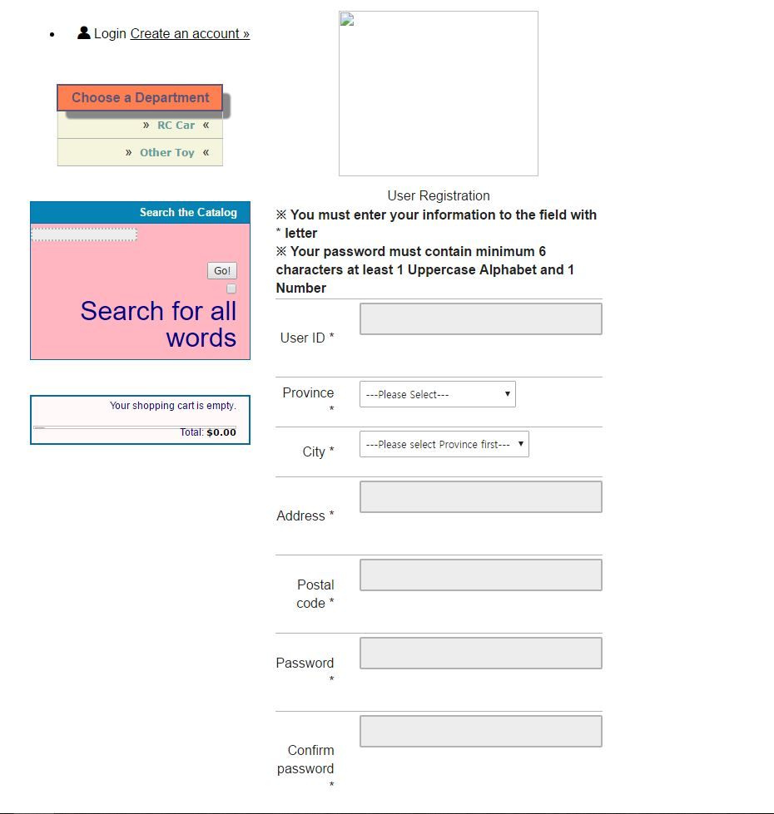

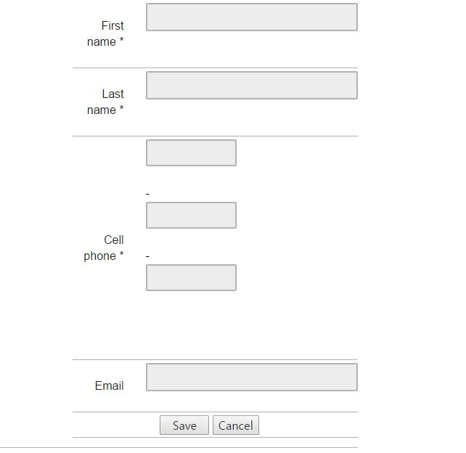

Validations for registration

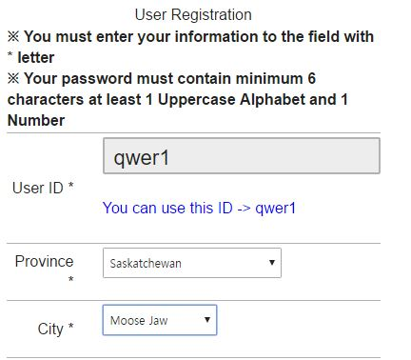

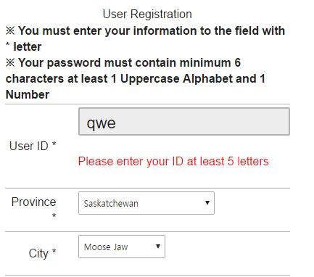

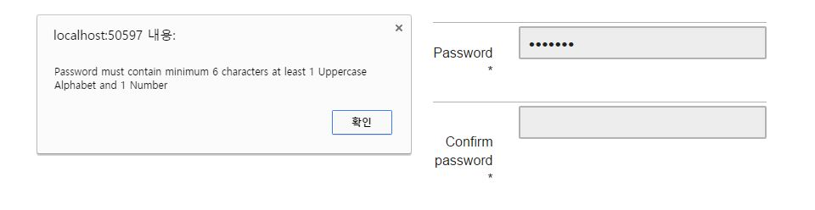

Login Page

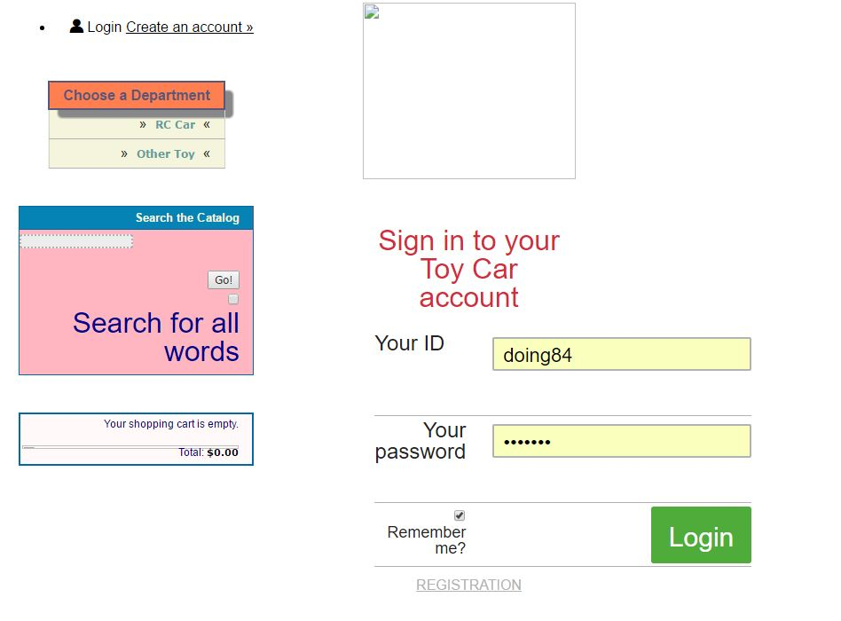

After Login

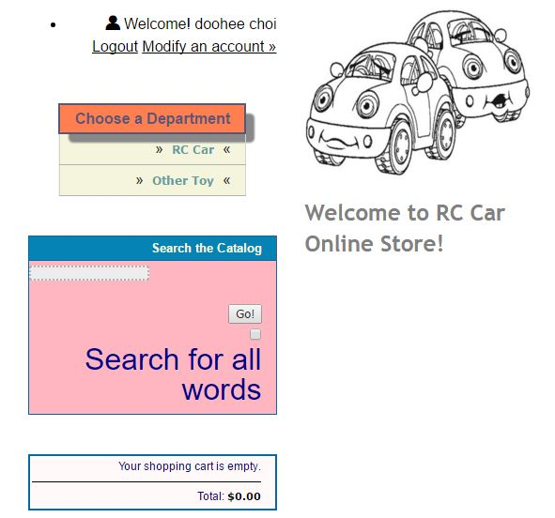

Can Modify Account

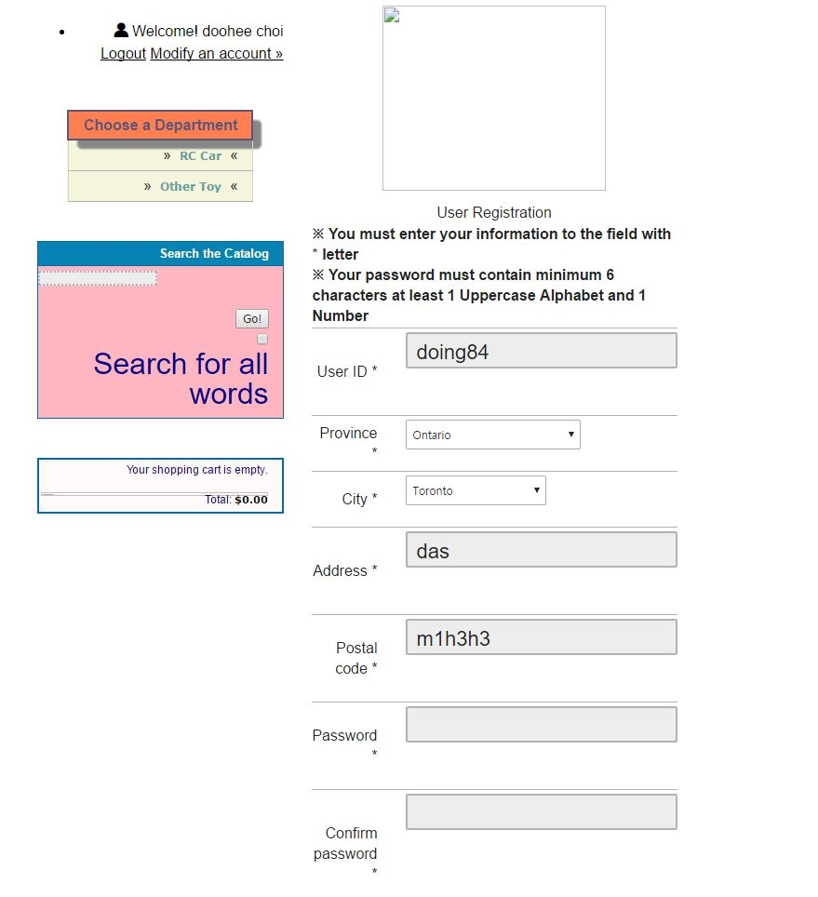

Can write review

